## Extreme Value Theorem

*If f is continuous on a closed interval $[a,b]$ then f has a minimum and maximum on the interval.*

The extreme value theorem guarantees the existence of extreme inside a closed interval if the function is continuous over that interval.

## Mean Value Theorem

*If f is continuous over the closed interval $\left[a,b\right]$ and differentiable over the open interval $(a,b)$ then there exists a number c in $(a,b)$ such that $f^{'}\left(c\right)=\frac{f\left(b\right)-f(a)}{b-a}$.*

The Mean Value Theorem guarantees that there is some point within the open with a slope equal to the average slope over the interval.

## Important Terms

Critical Numbers:

*The number c is a critical number if f is defined at the value and $f^{'}\left(c\right)=0, or f^{'}\left(c\right)=DNE$* .

A critical point is the critical number and its corresponding y value, $\left(c,f\left(c\right)\right).$ Critical numbers can either be relative extrema or points of inflection

Relative Extrema:

Relative extrema are comprised of two types.

If there is an open interval containing c on which $f\left(c\right)$ is a maximum, then $f\left(c\right)$ is called a relative **maximum** of $f$, or so you can say that $f$ has a relative **maximum** at $\left(c, f\left(c\right)\right).$

If there is an open interval containing c on which $f\left(c\right)$ is a minimum, then $f\left(c\right)$ is called a relative **minimum** of $f$, or so you can say that $f$ has a relative **minimum** at $\left(c, f\left(c\right)\right).$

Absolute Extrema:

Let $f$ be defined on an interval $I$ containing c.

$f(c)$ is the absolute maximum of $f$ on $I$ if $f\left(c\right)≥f\left(x\right)$ for all $x$ in $I$

$f(c)$ is the absolute minimum of $f$ on $I$ if $f\left(c\right)≤f\left(x\right)$ for all $x$ in $I$

Increasing/Decreasing:

A function $f$ is increasing on an interval if for any two numbers $x_{1}$ and $x_{2}$ in the interval, $x_{1}<x_{2}$ implies that $f\left(x_{1}\right)< f\left(x_{2}\right)$

A function $f$ is decreasing on an interval if for any two numbers $x_{1}$ and $x_{2}$ in the interval, $x_{1}<x_{2}$ implies that $f\left(x_{1}\right)> f\left(x_{2}\right)$

Concavity:

Let $f$ be differentiable on an open interval $I$. The graph of $f$ is concave upward on $I$ when $f^{'}$ is increasing on the interval and concave downward on $I$ when $f'$ is decreasing.

Points of Inflection:

Let $f$ be a function that is continuous on an open interval, and let c be a point in the interval. If the graph of $f$ has a tangent line at this point $\left(c, f\left(c\right)\right),$ then this point is a point of inflectioin of the graph of $f$ when the concavity of $f$ changes from upward to downward (or downward to upward) at the point.

## The First Derivative Test

The first derivative test is used to determine whether a located critical point is a relative minimum, maximum, or neither.

The test:

Let c be a critical number of a function $f$ that is continuous on an open interval $I$ containing c. If $f$ is differentiable on the interval, except possibly a c, then $f\left(c\right)$ can be classified as follows.

If $f'(x)$ changes from negative to positive at c, then $f$ has a relative minimum at $\left(c, f\left(c\right)\right).$

If $f'(x)$ changes from positive to negative at c, then $f$ has a relative maximum at $\left(c, f\left(c\right)\right).$

If $f'(x)$ is positive on both sides of c or negative on both sides of c, then $f(c)$ is neither a relative minimum or maximum.

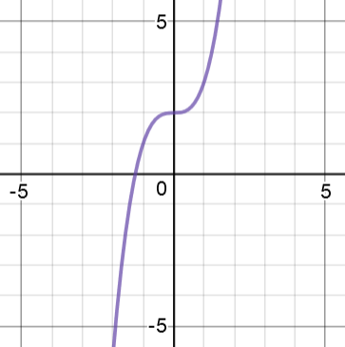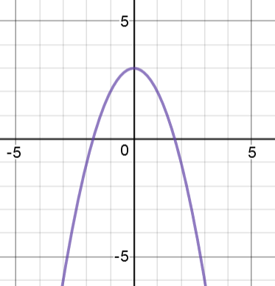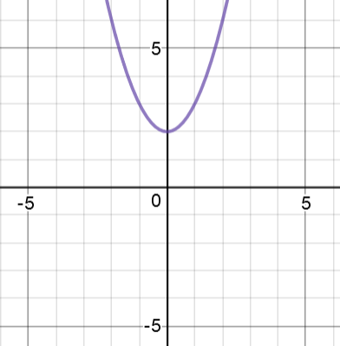 $f\left(x\right)=x^{2}+2 g\left(x\right)= -x^{2}+3 h\left(x\right)=x^{3}$

----------0+++++++ ++++++++0------------- ++++++++0+++++++

$f$ 0 $g$ 0 $h$ 0

## The Second Derivative Test

The second derivative test another way we can test critical points for extrema.

The test:

Let $f$ be a function where $f^{'}\left(c\right)=0$ and the second derivative of $f$ exists on an open interval containing c then

If $f^{''}\left(c\right)>0,$ then $f$ has a relative minimum at $(c,f\left(c\right))$

If $f^{''}\left(c\right)<0,$ then $f$ has a relative maximum at $(c,f\left(c\right))$

If $f^{''}\left(c\right)=0$ then the test has failed and the first derivative test should be used, which can’t fail.

Let’s try the second derivative test with the same three functions

$$f\left(x\right)=x^{2}+2 g\left(x\right)= -x^{2}+3 h\left(x\right)=x^{3}$$

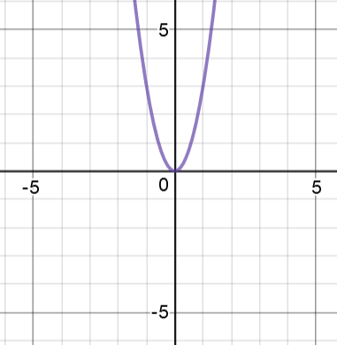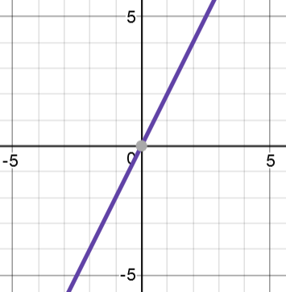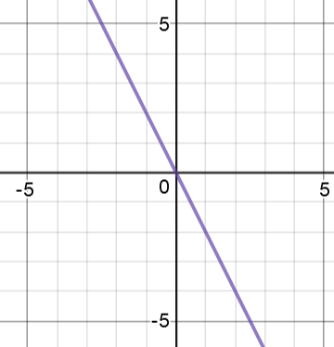

*f’ g’ h’*

$h^{'}\left(0\right)=0$ so we can use the first derivative test

$h^{''}\left(x\right)=0$ so we cannot determine whether $(0,2)$ is a rel. min, rel. max, or neither

$f^{'}\left(0\right)=0$ so we can use the first derivative test

$f^{''}\left(0\right)=2>0$ so (0,2) is a rel. min for $f$

$g^{'}\left(0\right)=0$ so we can use the first derivative test

$g^{''}\left(0\right)=-2<0$ so (0,2) is a rel. max for $g$

## Position, Velocity, and Acceleration

The relationship between position, velocity, and acceleration graphs may help you better understand the graphs of $f(x), f^{'}(x)and f''(x)$.

If $s(x)$ is a position vs time graph, $v(x)$ is the corresponding velocity vs time graph, and $a\left(x\right)$ is the corresponding acceleration vs time graph, then $s{\left(x\right)}^{''}=v^{'}\left(x\right)=a(x)$. In other words, acceleration is the derivative of velocity, which is the derivative of position. Lets take a look at some graphs to see this relationship.

-x2 +4x + 8

$$s\left(x\right)=-x^{2}+4x+8 s'\left(x\right)= -2x+4 s''\left(x\right)=x^{3}$$

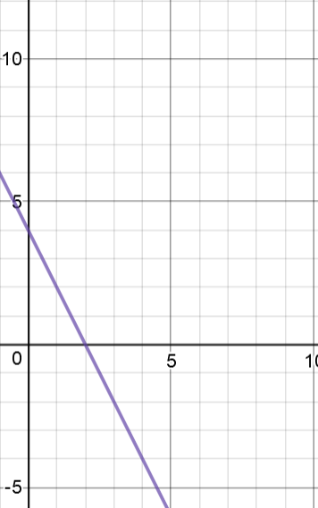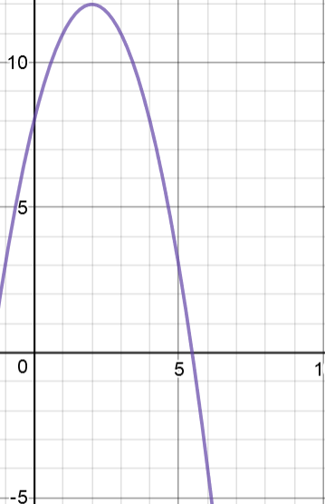

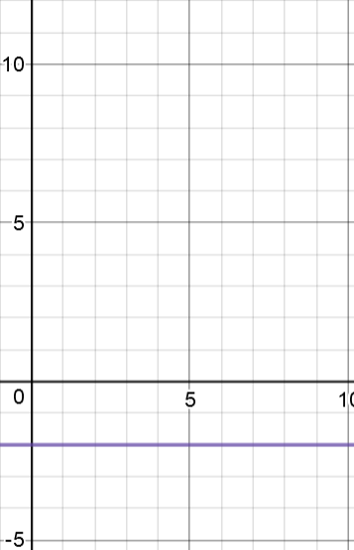

Position Velocity Acceleration

## Related Rates Problems

Steps for solving Related rates problems:

|  |  |
| --- | --- |
| Step 1 | * Draw A picture * Assign variables to quantities that vary * Label all given values but only label “always values on the diagram |
| Step 2 | Write an equation that relates the variables whose rates of change are given and needed |
| Step 3 | Differentiate implicitly with respect to t |
| Step 4 | Substitute all known values to find the needed rate of change |

**EXAMPLE 5:**

Thecubicle.us sells their top cube lubricant, DNM37, inside a conical bottle. The bottle is filled completely and 4 inches tall and the diameter of the base is 2 inches. When releasing it from the bottle it flows at $\frac{1}{2} in^{3}/sec$ How fast is the liquid level dropping when it is 2 inch deep?

Diagram:

Equation:

$$V=\frac{πr^{3}h}{3}$$

$$V=\frac{πh}{3}$$

Derive:

$$\frac{dV}{dt}=\frac{π }{3}\frac{dh}{dt}$$

$$-\frac{1}{2}=\frac{π dh}{3 dt}$$

$$-\frac{3}{2π}=\frac{ dh}{dt}$$

$\frac{dh}{dt}= -\frac{3}{2π}\frac{in}{s}=\frac{0.477in}{s}$

Given:

$$\frac{dV}{dt}=-\frac{1 in}{2 s}$$

$$h=2 in$$

Find: $\frac{dh}{dt}$

## Optimization Problems

Steps for solving optimization problems:

|  |  |
| --- | --- |
| Step 1 | * Draw a picture * Identify quantities to be optimized |
| Step 2 | Write a primary equation isolating the variable to be optimized |
| Step 3 | Write a secondary equation relating non-optimized variables from primary equation |
| Step 4 | Combine the primary and secondary equation into an objective equation with two variables |
| Step 5 | Find Feasible domains |
| Step 6 | Optimize the objective equation   * Find critical points * Check for correct extrema * Answer in units |

**EXAMPLE 6:**

The organizers of a Rubik’s Cube competition want to rope off the solving area to prevent spectators from getting too close to the competitors. They have 100ft of rope in order to separate this area against the back wall, so only 3 sides are needed. What is the maximum possible area of the competing area and what are its dimensions?

Diagram:

Optimize:

$$A^{'}=100-4l$$

$$0=100-4l$$

$$l=25 feet$$

Evaluate

$$l=25 feet$$

$$2\left(25\right)+w=100$$

$$w=50 feet$$

$$A=50\left(25\right)=1,250 feet^{2}$$

Primary equation:

$$A=lw$$

Secondary equation:

$$2l+w=100$$

Objective Equation:

$$A=l\left(100-2l\right)=100l-2l^{2}$$

Domain:

$$l∈(0,50)$$